# Fusion 360

# 3d printer control

Nozzle – 220

Bed – 60

fan - 100

## download

[download](https://www.autodesk.com/products/fusion-360/personal)

## Tutorial

[tutorial](https://productdesignonline.com/fusion-360-tutorials/fusion-360-new-ui-vs-old-ui-august-2019-update/)

# shortcuts

Line – L

Circle – c

# Create rectangle box

## Create project

## Change active unit

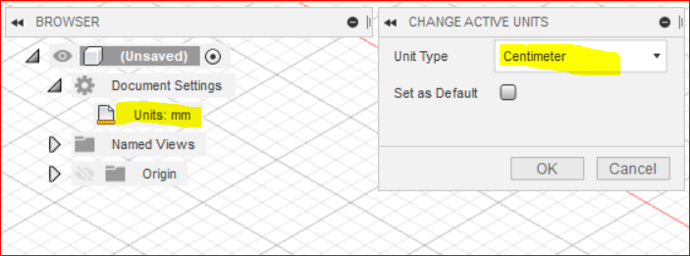

## New component

Assemble->new component

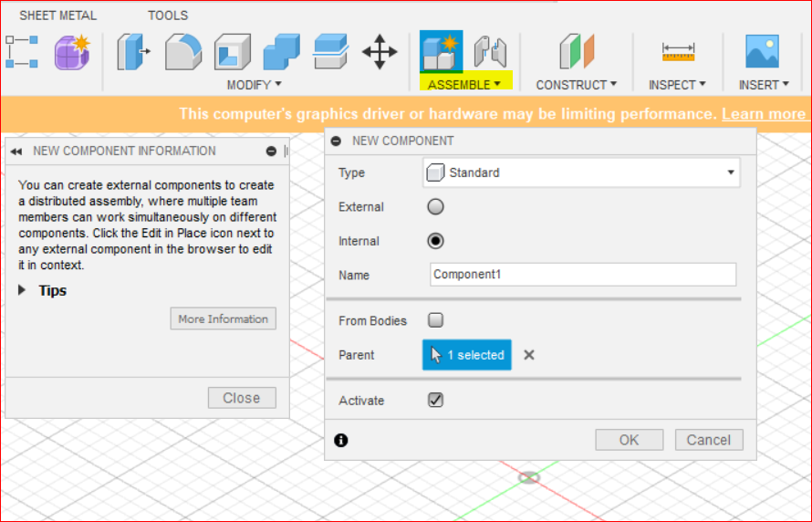

Name : lego

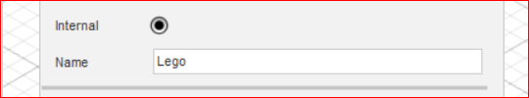

## Create 2 point rectangle

Create new Sketch(left side + icon) -> select a plane -> select two point rectangle (r)

* Click the origin
* Drag
* 15.8 in x and press tab
* 31.8 in y
* Extrude(e) – 9.8

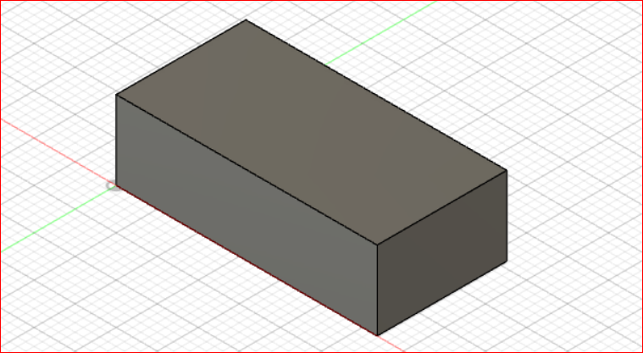

## Create circle

Create new sketch -> select top of rectangle -> create circle(c)

Press (d) for dimension -> select center of circle and top edge of rectangle -> click and drag out the dimension

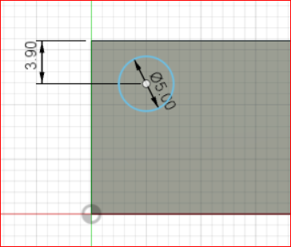

* Right click -> repeat sketch dimension
* Set the same dimension in vertical

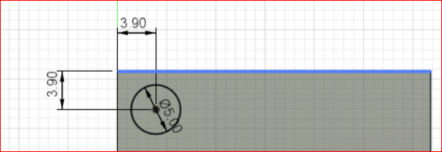

* Extrude (e) -> select circle -> 1.7

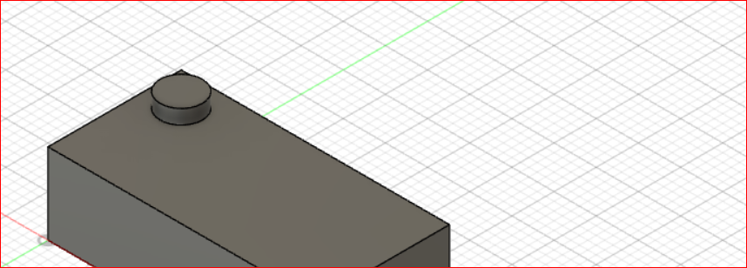

## Create rectangle pattern

* On solid tab -> pattern -> create rectangle pattern
* Select regular pattern

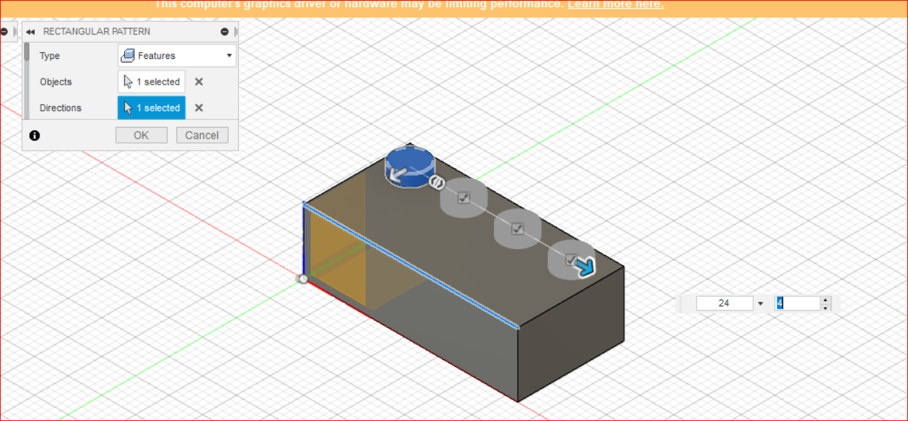

* Select features
* Objects -> select extrude in bottom

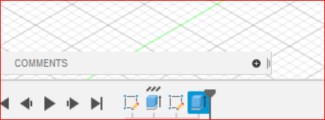

* Select direction – 24 x 4
* Select other direction
* 8 x 2

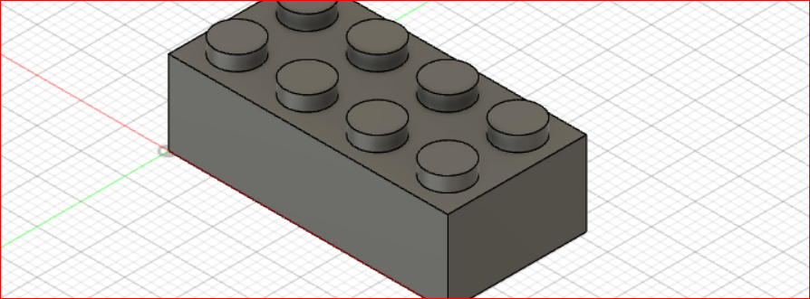

## shell

* Modify -> shell
* Faces/body select bottom face
* Inside thickness 1.49

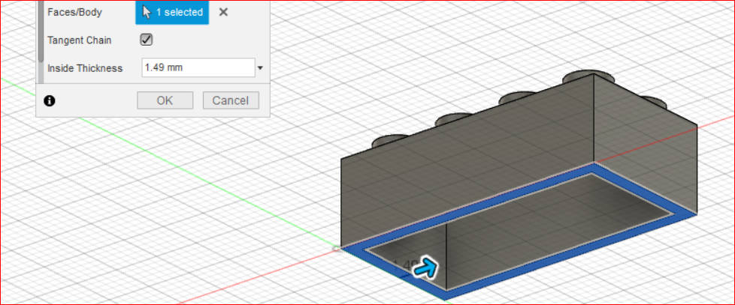

## Create sketch inside face

Right click inner face

* Create sketch
* Press (l) for line -> construction
* Select 1st row second circle center point
* Select 2nd row 1st circle center point

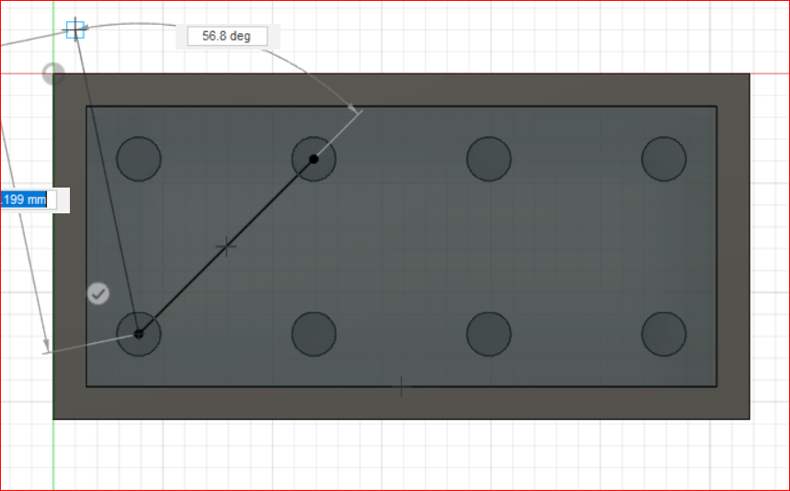

* Press (c) for center circle
* Off construction in dialog box
* Select mid point of line
* Select the tangent of 2nd circle
* Press O for offset
* Select circle -> set diameter 1
* Flip the circle inside

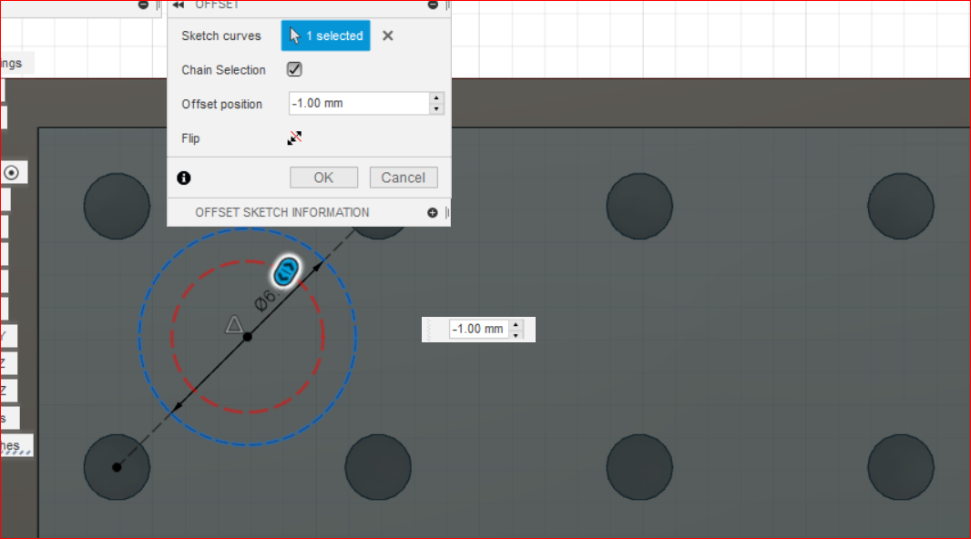

* Press e for extrude
* Select circle
* Extrude 8.1

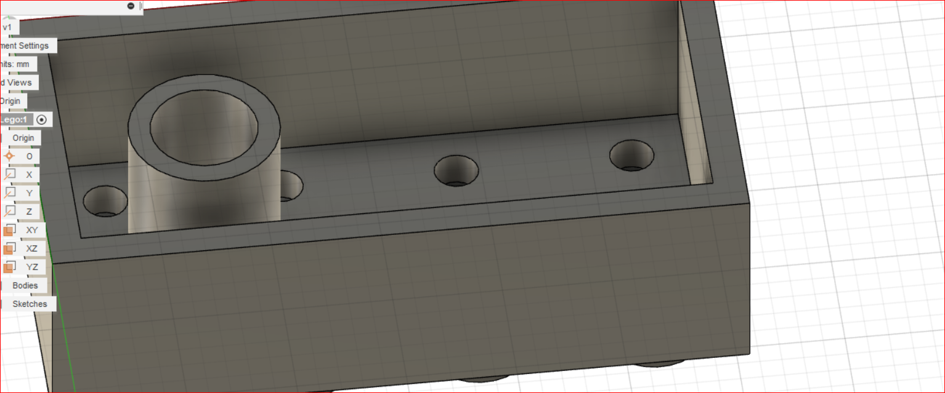

Select pattern

* Create ->pattern -> rectangular pattern
* Distance 16 x 3

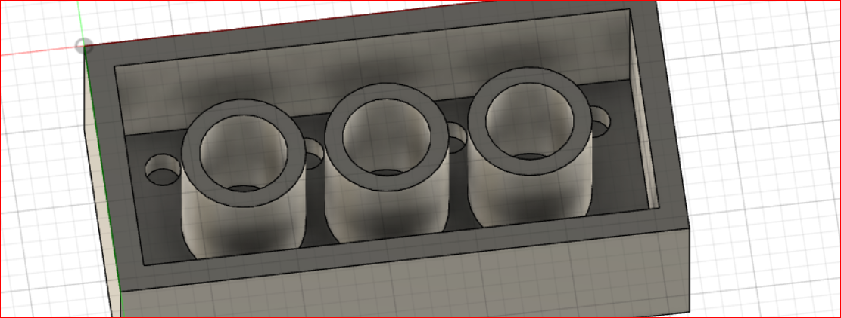

## Remove sharpen edge – fillet(f)

Modify -> fillet (f)

* Select edges
* 0.2

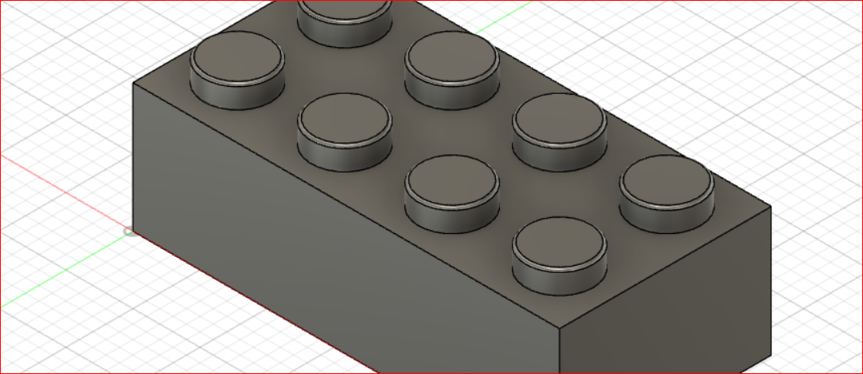

# Bottle

[tutorial](https://productdesignonline.com/fusion-360-tutorials/create-a-beer-bottle-in-fusion-360/)

1. Create new component
   1. On solid plane
   2. Create
   3. New component
   4. Name: beer bottle
2. Attatch bottle image
   1. [Download](https://productdesignonline.com/wp-content/uploads/2019/05/beer-bottle-png-product-design-online.png) image
   2. Insert -> canvas -> open image -> select xy plane -> rescale -> ok
3. Calibrate image
   1. Browser -> beer bottle -> beer bottle -> canvas -> select image
   2. Right click image ->calibrate
   3. In 3d view-> select front
   4. Select the bottom right point, top right point
   5. Set dimension 240

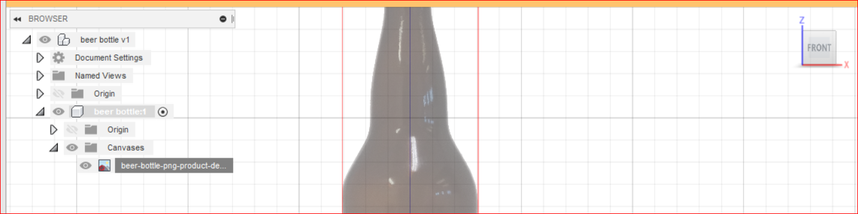

1. Create line
   1. Press L
   2. Select top mid point
   3. Select bottom mid point, continue
   4. Set dimension 30 select bottom right point, continue
   5. Set 134, select top right corner

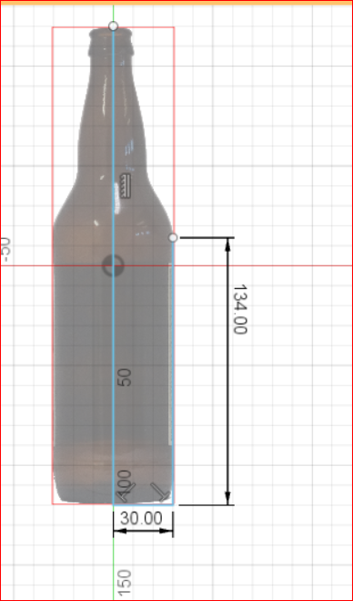

1. Sketch point
   1. Create -> point
   2. Select other sides

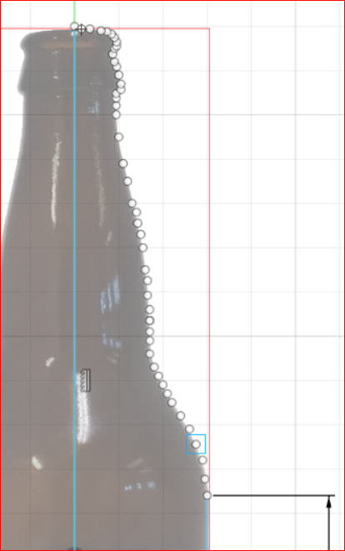

1. Spline
   1. Create -> spline-> fit point spline

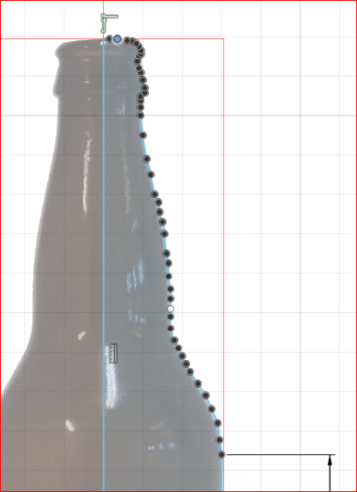

1. Revolve
   1. Solid
   2. Create
   3. Revolve
   4. Select pivot
   5. Select axis

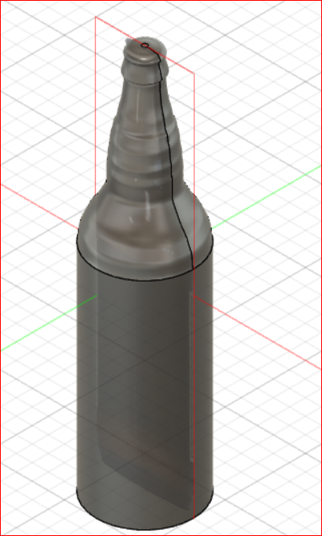

1. Fillet
   1. Press f
   2. Select bottom circle – 5
   3. Select top circle – 1
2. Make top as hollow
   1. Double click sketch in bottom left corner(menu)
   2. Modify -> shell ->
   3. Browse -> Bodies -> Body
   4. In shell thickness 3
   5. Inspenct -> section analysis
   6. Browser -> origin -> xz
   7. Select top face
   8. Press c
   9. Click the center of bottle top
   10. Drag 14 mm
   11. Select circle
   12. Extrude e
   13. Operation cut
   14. Extent – two object selection or scale the length up -> ok
3. Fillet the inner edge to 2
4. Select -> browse -> analysis
5. Glass appearance
   1. Deselect browse -> canvases
   2. Select body
   3. Right click -> appearance
   4. Drag and drop glass appearance

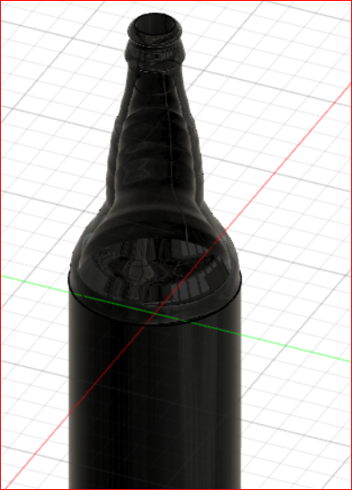

# Paper clip

1. Press l
2. Select xy
3. Click origin
4. Drag top 20 mm

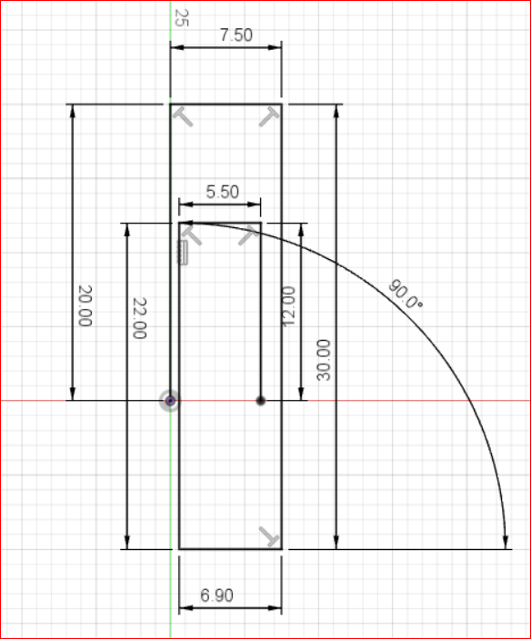

1. Press s for shortcut search
2. Search fillet -> select 2d fillet
3. Select top 2 corners

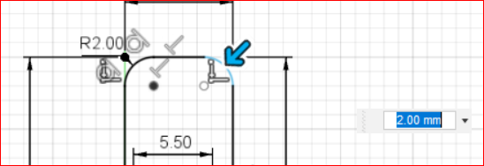

1. Mark 3.75
2. Right click -> repeat fillet -> select bottom 2 corners 3.25
3. Select last 2 corner 2.75
4. Select finish sketch in top right menu
5. Press c
6. Select xz
7. Select origin -> drag -> 1mm
8. Select home icon
9. Sweep
   1. Create-> sweep
   2. Profile -> circle
   3. Path -> line

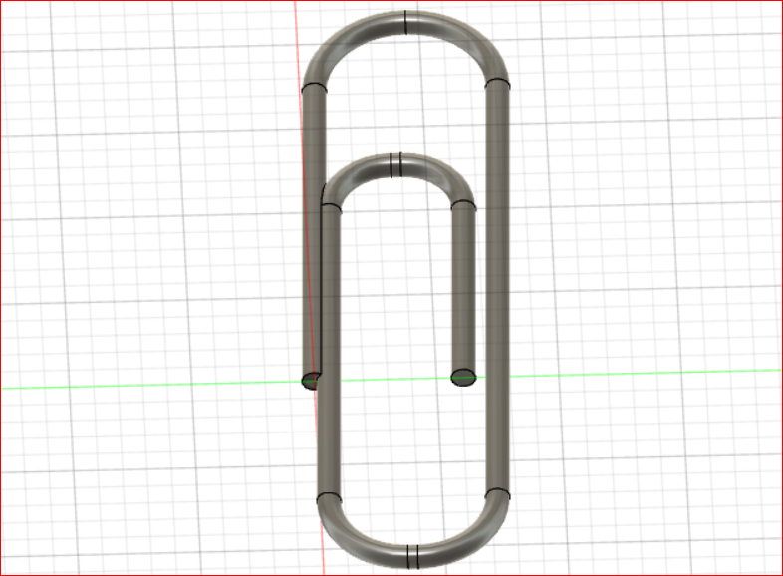

# Whiskey bottle

1. Assembly -> new component -> name: whiskey bottle
2. Press c -> xy plane
3. Press r -> center rectangle -> w: 76, h:63
4. Press s
   1. Search fillet
   2. Select sketch fillet
   3. Select all edges : 7mm
   4. Finish sketch
5. Construct -> offset
   1. Select xy plane
   2. Distance: 114
6. Press r
   1. Select 2nd plane
   2. Center rectangle
   3. W:95, h:76
7. Search s
   1. Select 4 corners
   2. 12
   3. Finish sketch
8. Construct -> offset plane -> d:38
9. Press c
   1. Select 3rd plane
   2. Radius 40mm
   3. Finish sketch
10. Construct -> offset plane
    1. Select 3rd plane
    2. D:89mm
11. Press c
    1. Select 4th plane
    2. R:30
12. Create
    1. Loft
    2. Select bottom to top
    3. Cancel
13. Select first sketch in timeline (bottom menu)
    1. Select line from toolbar(l)
    2. Select construction in sketch pallet
    3. Select mid point in right side of rec
    4. Select mid point of left side of rec
    5. Finish sketch
14. Repeat step 13 for 2nd sketch
15. Select 3rd sketch
    1. Press l
    2. Pres x
    3. Select mid point of circle
    4. Select left side
    5. Finish sketch
16. Repeat step 15 for sketch 4
17. S
    1. S: Split
    2. Fit point spline
    3. Press xz plane
    4. Select 1st 3 points
    5. enter
    6. Adjust radius

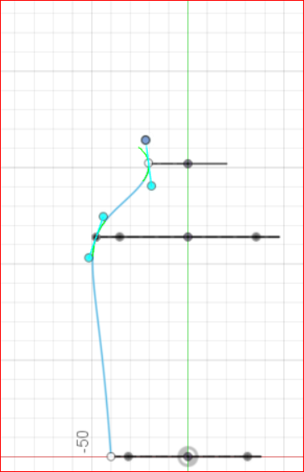

1. Press l
   1. Select 3rd and 4th point
2. Select end of 3rd point
   1. Make it as mid point of last line

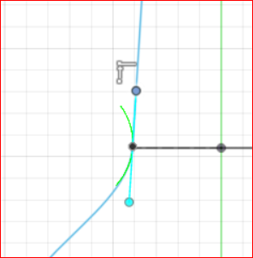

1. Press l
   1. Click bottom of the line

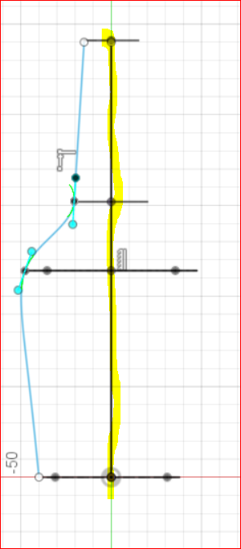

1. Create -> mirror
   1. Select two sides
   2. Mirror line is the vertical center line
2. Create
   1. Loft
   2. Press home icon to isotropic view
   3. Select bottom to top
   4. Select + icon in guide rule

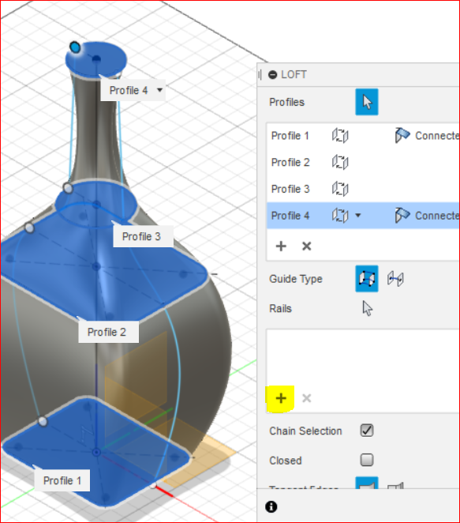

* 1. Select line 1 and press + icon select line 2

1. F
   1. Select bottom circle
   2. 5mm
2. C
   1. Select top surface
   2. D:27
3. E
   1. Select top circle
   2. 12mm
4. Modify
   1. Shell
   2. Select top circle
   3. 3mm
5. Thread
   1. Create
   2. Thread
   3. Check modeled : true
   4. Uncheck full length: drag down one thread: 10mm
   5. Ok
6. Select body
   1. Right click appearance
   2. Drag glass bronze
7. In bottom menu
   1. Display
   2. Environment
   3. Dark theme

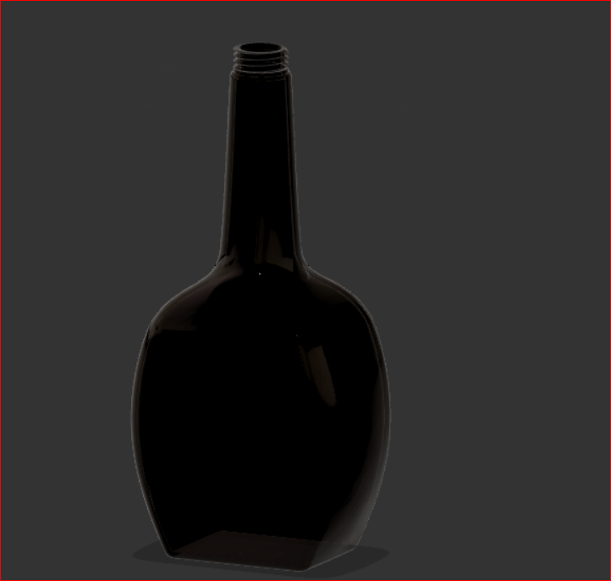

# Ice cube

- r

- select xy plane

- unit inch

- select center point rectangle

- select 1st point as center

- w:12 h:4

1. Extrude

* Select plane
* H:2inch

1. Draw rec tangle in top
   1. R
   2. Select top surface
   3. Draw rec in bottom left corner
   4. W: 1.2, h:1.65
   5. D
   6. Select bottom edge of small rec
   7. Select bottom edge of outer rec
   8. D:0.2in

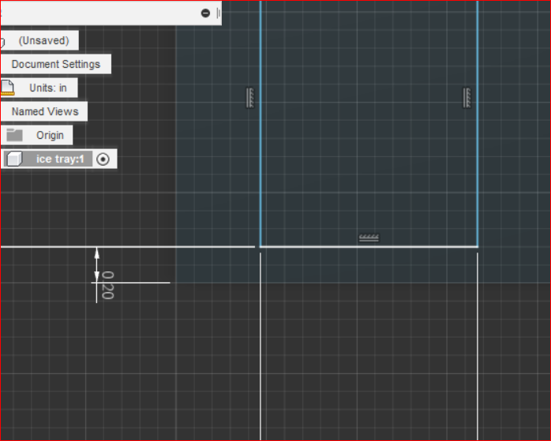

1. Repeat 2.e to 2.h for left corner of both rec
2. Extrude inner rec
   1. E
   2. Select small rec
   3. D: -1.3
   4. Angle: -10

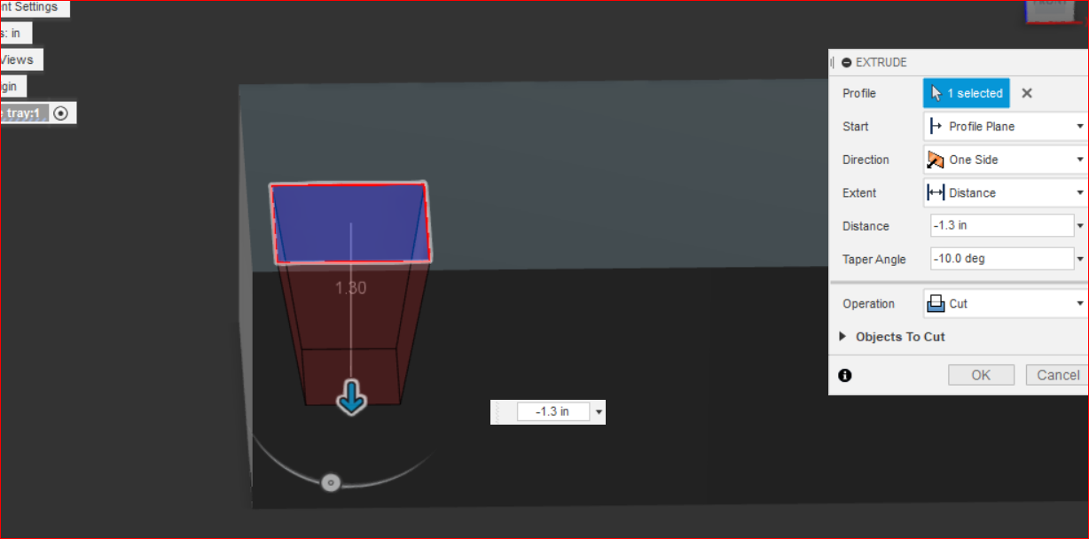

1. Fillet
   1. F
   2. Select all edges of inner rec
   3. 0.13
2. Rectangular pattern
   1. Create
   2. Pattern
   3. Rectangular pattern
   4. Change select mode to features
   5. Select extrude and fillet in bottom menu
   6. -10.4x8, -1.9x2

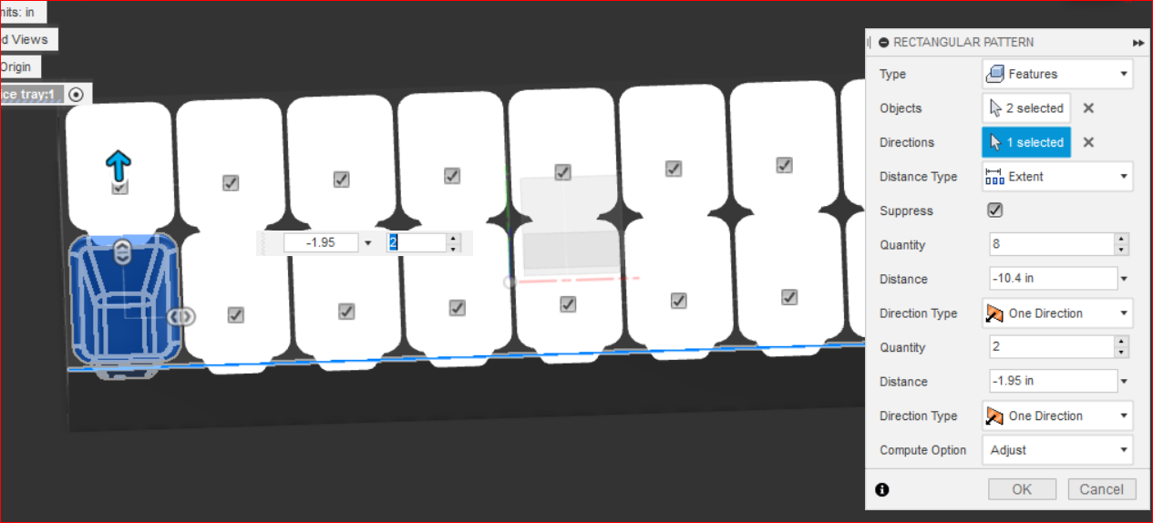

1. Shell
   1. Search shell
   2. Select 4 sides and bottom side
   3. Thickness : 0.07
2. Fillet all 4 edges
   1. F
   2. Select corners of outer rec
   3. 0.4
3. Corner
   1. Create -> new sketch
   2. Select xz plane
   3. Zoom left bottom corner

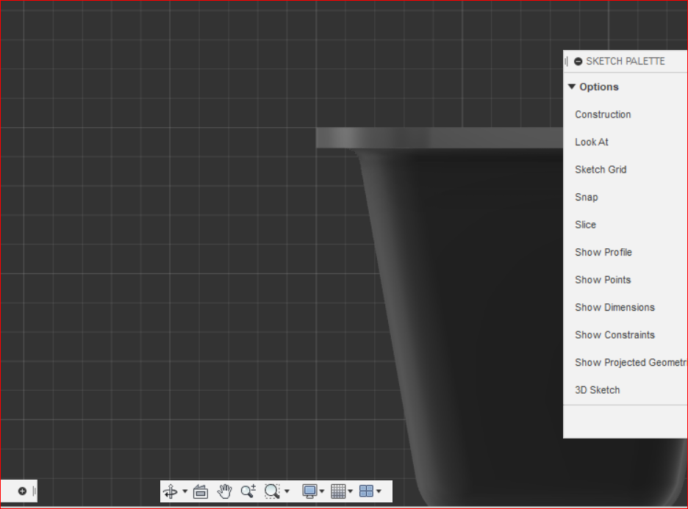

* 1. L
  2. Select top
  3. (V )Drag down 0.25in
  4. (<) 0.25in
  5. (^) 0.07in
  6. Select 1st selected point
  7. (<) 0.07
  8. Drag reference line to both point

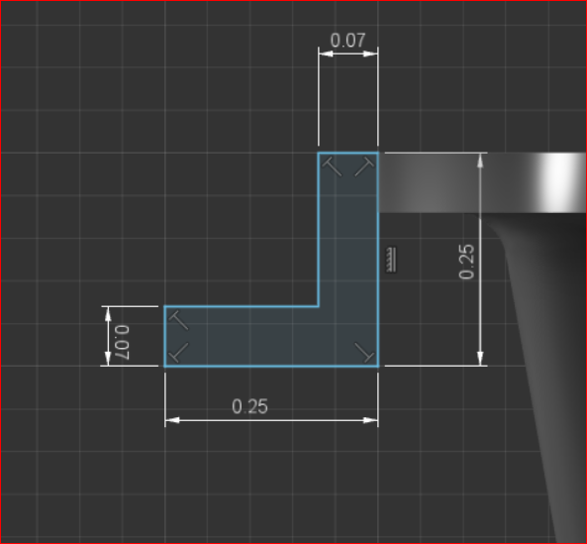

* 1. Fillet(f)
  2. Select bottom edge and inner edge fillet=0.05

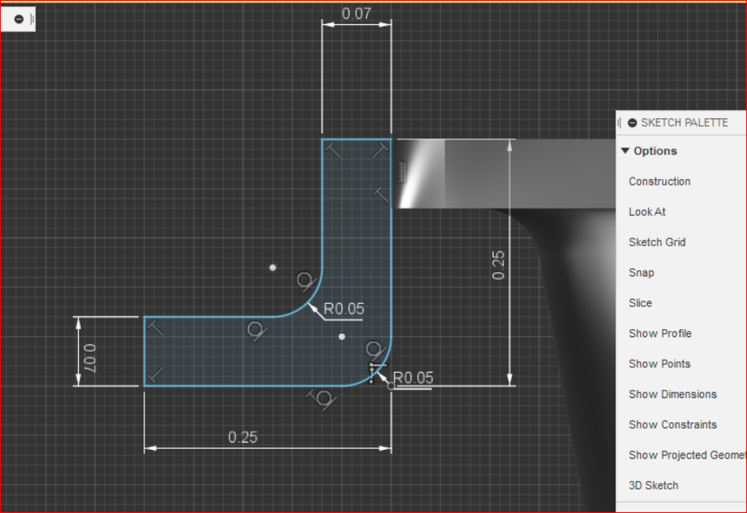

* 1. Finish sketch

1. Create -> sweep
   1. Select profile as object as created
   2. Select path as edge

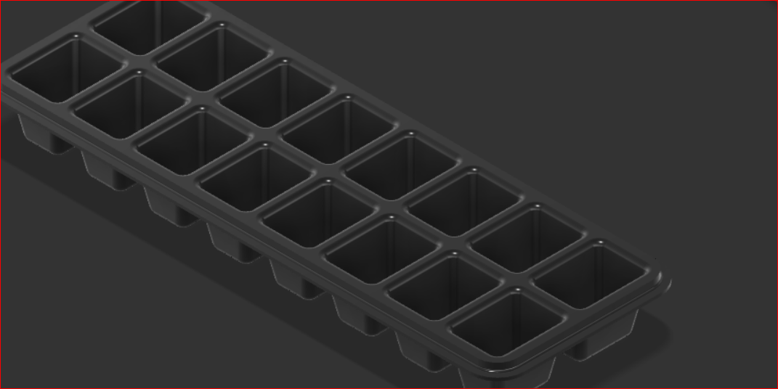

1. Appearance -> plastic blue

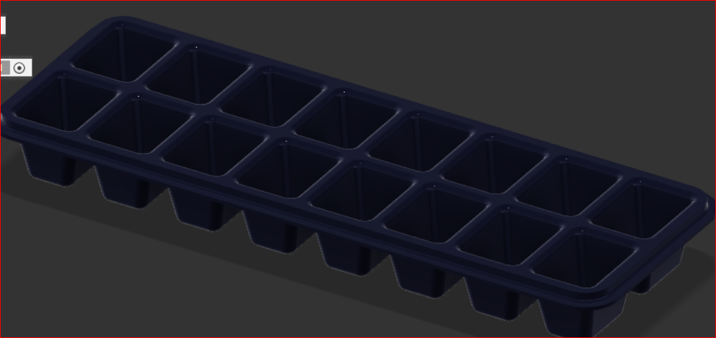

# Android 3d model

[Youtube](https://www.youtube.com/watch?v=5wcrd0z3Zg4)

1. L
2. Select xz plane
3. Line vertical : 100mm – start point origin
4. Line horizontal right 38 - start point origin
5. Finish sketch
6. Solid
   1. Revolve
   2. Select plane
   3. Select axis (line starting at origin)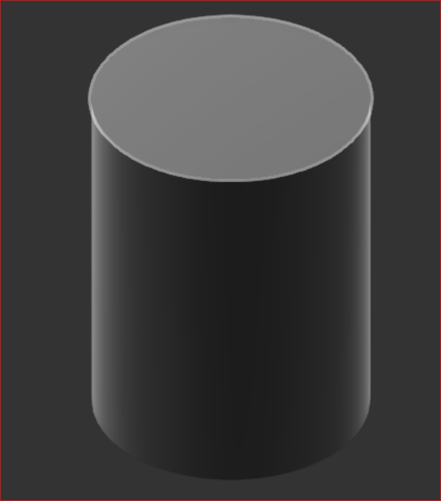

## Create leg

1. Select front view
2. L
3. Select middle bottom

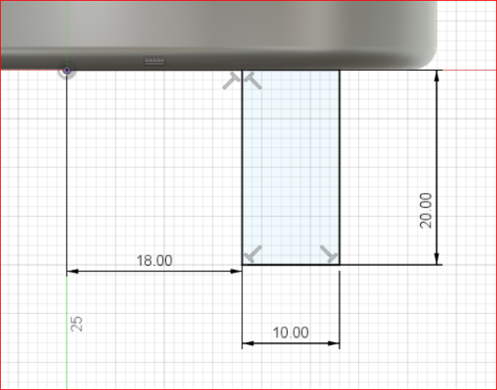

1. Create arc
   1. Create -> arc -> center point arc

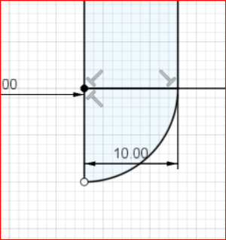

1. Finish sketch
2. Select revolve
   1. Select plane and axis

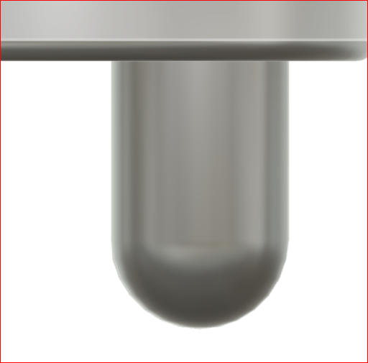

1. Create 2nd leg
   1. Crate -> mirror
   2. Type -> features
   3. Select xz plane

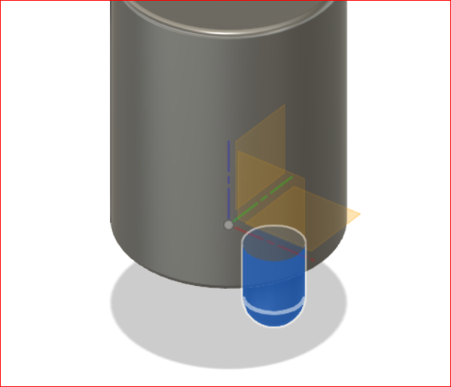

## Create hand

1. Hand dimeter : 20
2. 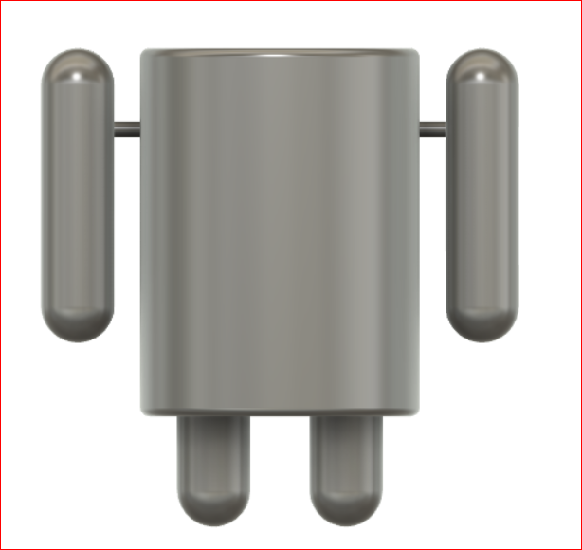

## Create hole in top

1. C
2. Select top plane
3. Crate circle with radius 70
4. Extrude

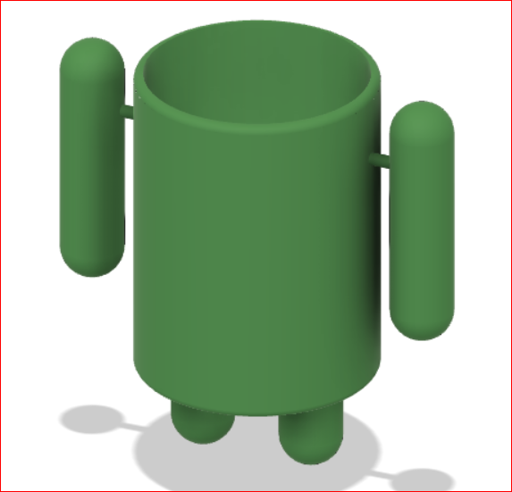

## Create bottom support

